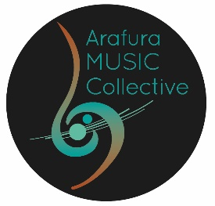
ARAFURA MUSIC COLLECTIVE INC SUPPORTER MEMBER APPLICATION FORM and PROCESS

Arafura Music Collective Inc is a non-profit organisation whose purpose is to:
- contribute to the creative and social capital of our intercultural community in the Northern Territory through the development, promotion, and performance of chamber music/small ensemble music in any of its forms and genres
- curate creative experiences that foster identity, community connection and respect for country
- promote chamber music of Northern Territory and Australian composers
- provide creative development for our community
- collaborate with artists of diverse music cultures and artforms

To apply to become a Supporter member of the Arafura Music Collective Inc association please:

a. Submit a written application for Supporter membership to the Board using this form (signed by you)

b. Be proposed by one member (member must sign)

c. If you are an organisation or corporation, include the name of a person as your representative.

The Board will process your Supporter membership and you will be informed via email asap.

Fees for AMC Inc Support membership are for a calendar year.

You can renew your membership without having to reapply.

PERSONAL INFORMATION:
Name:
Email:
Birthdate (optional)
Phone Number:

PROPOSER
AMC Inc Proposer |  | Signature
Email:
Phone Number:

MEMBERSHIP FEE
Upon acceptance as a supporter member, please deposit your $20 membership in the AMC Inc bank account
BSB 035302 | Acc No 566800
Please reference your family name and AMC Inc supporter.
Signature:

Date:

