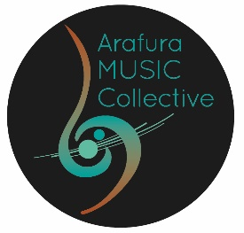
ARAFURA MUSIC COLLECTIVE MEMBERSHIP APPLICATION FORM
ARTIST MEMBER

PERSONAL INFORMATION:
Name:
Date of Birth:
Email:
Phone Number:
Address:

MUSIC/ PROFESSIONAL INFORMATION
Instrument(s) Played:
Years of Experience:
Musical Background/Bio: Please provide as an attachment a word doc (between 200 -500 words) of your musical education, background and experience. Include any experience collaborating with musicians from diverse musical genres and cultures. This bio may used for grant applications and programs. Should this be the case you will be informed. Please include links to any recordings or performances to support your application
Please indicate commitment to the values and ethos of Arafura Music Collective:

Artistic Excellence and Integrity | Our artistic practice is one of continuous learning, and authenticity grounded in respect for cultural diversity
Innovation | Our community is engaged through unique and creative practices and performances derived from diverse cultural traditions and performance genres.
Community | we are a community of audience and performing artists that supports and honours diversity, access, and inclusion.
Collaboration | we engage in interdisciplinary and intercultural collaborations with the musicians and arts organisations of our city, region, and country.

Please tick your agreement with the following statements

1 Have read the AMC values
2 I support and endorse the AMC values

PROPOSER
AMC Inc artist proposer | Claire Kilgariff | Signature
Email: | clairekilgariff@bigpond.com
Phone Number: | 0401119108

MEDIA CONSENT
Please check the box below to opt out of using photos and videos of performances for marketing (social media) and grant submission evidence

MEMBERSHIP FEE
Please tick the applicable field below
 | I will deposit my $40 member ship in the AMC Inc bank account  Reference AMC Inc Player Fee + family name | BSB 035302 | Acc No  566800

DECLARATION:
By signing below, I confirm that all the information provided in this application is true and accurate to the best of my knowledge. I understand that the submission of this form does not guarantee membership in Arafura Music Collective, and that the final decision is at the discretion of the selection committee.

Signature:

Date:

